K - Means elbow method
The elbow method finds the optimal value for k (#clusters).

Determine optimal k : The technique to determine K, the number of clusters, is called the elbow method.

plot:
- values for K on the horizontal axis
- the distortion on the Y axis (the values calculated with the cost function).
This results in:
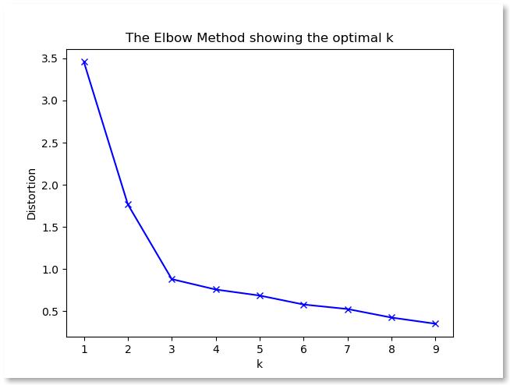
When K increases, the centroids are closer to the clusters centroids.
The improvements will decline, at some point rapidly, creating the elbow shape.
That point is the
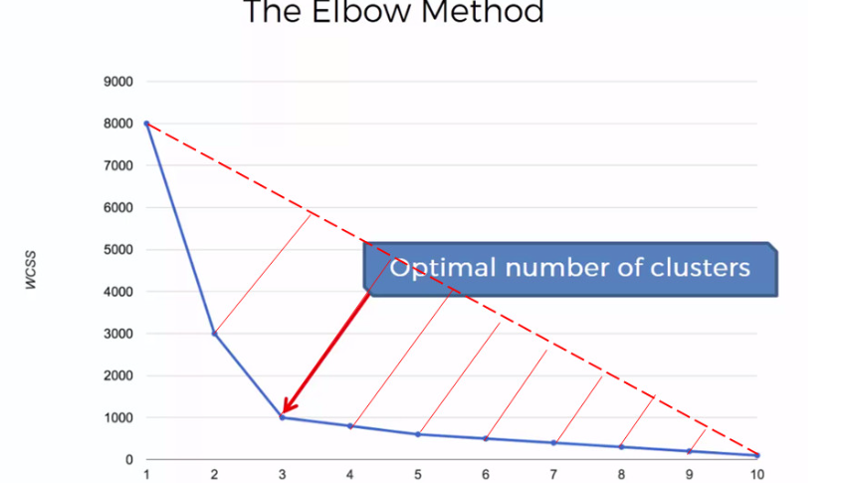

K-Means: Inertia
----------------------
Inertia measures how well a dataset was clustered by K-Means.
It is calculated by measuring the distance between each data point and its centroid, squaring this distance, and summing these squares across one cluster.
A good model is one with low inertia AND a low number of clusters (K).
However, this is a tradeoff because as K increases, inertia decreases.

Silhouette Coefficient
The Silhouette Coefficient (sklearn.metrics.silhouette_score) is an example of such an evaluation, where a higher Silhouette Coefficient score relates to a model with better defined clusters.
The Silhouette Coefficient is defined for each sample and is composed of two scores:
a: The mean distance between a sample and all other points in the same class.
b: The mean distance between a sample and all other points in the next nearest cluster.
The Silhouette Coefficient s for a single sample is then given as:
s=b−a/max(a,b)
The Silhouette Coefficient for a set of samples is given as the mean of the Silhouette Coefficient for each sample.

